Quiz 1

Question 3.

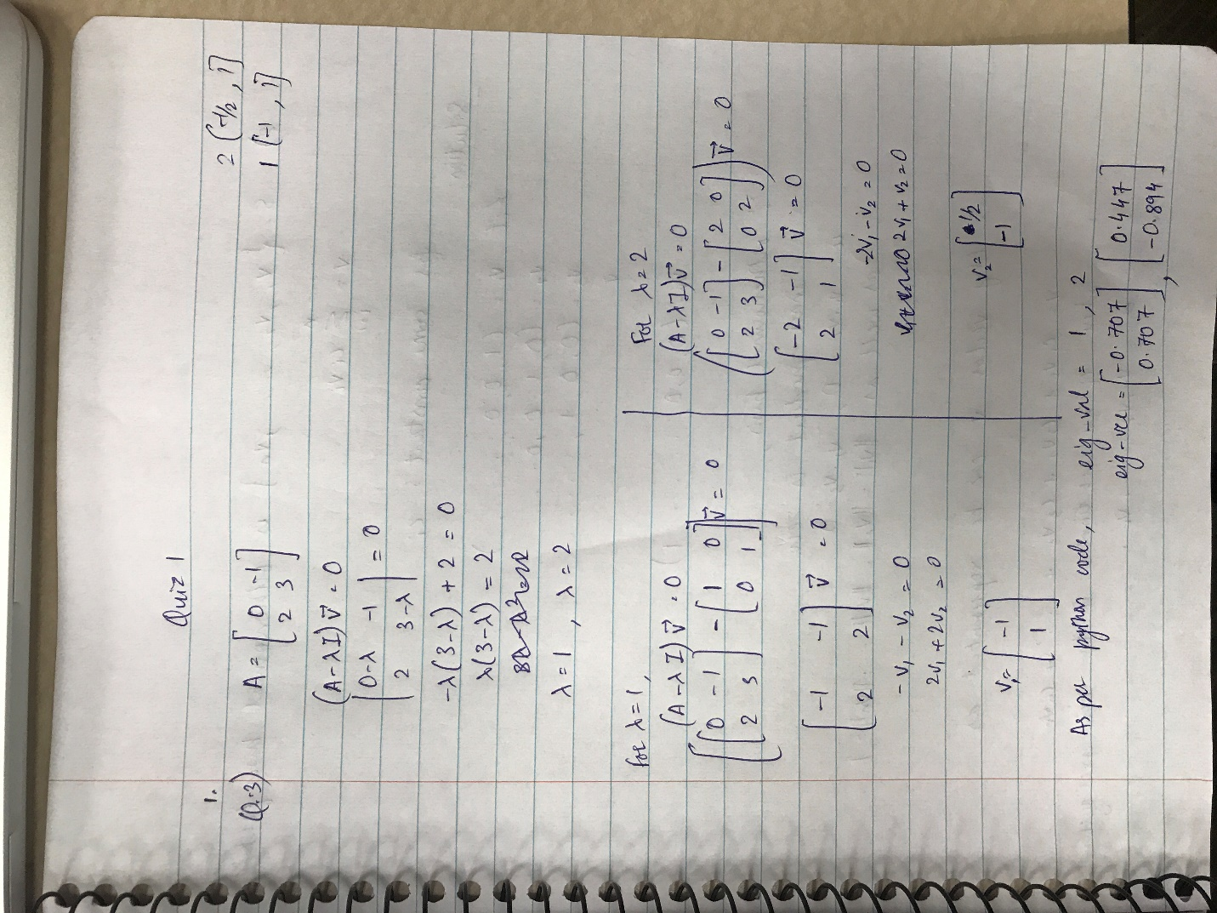

The eigen values are same in both solutions and the eigen vector have the same ratio.

Question 2.

